Article 21 — The Resilience Layer
Michal Doroszewski

The System That Refused to Break
You’re watching a control room during a storm. The power flickers. The network stutters. The sensors go offline. Screens flash red, then black, then blue. A technician mutters, “We’ve lost telemetry.” Another says, “Failover triggered.” A third says, “We’re still operational.”
The system isn’t perfect. It isn’t uninterrupted. It isn’t immune to failure. But it is resilient. It reroutes traffic, rebalances load, re‑evaluates posture, re‑authenticates users, and re‑establishes trust. It doesn’t panic. It doesn’t collapse. It doesn’t blame. It absorbs the disruption, adapts, and continues.
That is the Resilience Layer — not the “uptime guarantee” kind, but the architectural kind. The kind that survives uncertainty, absorbs instability, and maintains functionality without perfect conditions. The kind that turns a fragile system into a durable one.
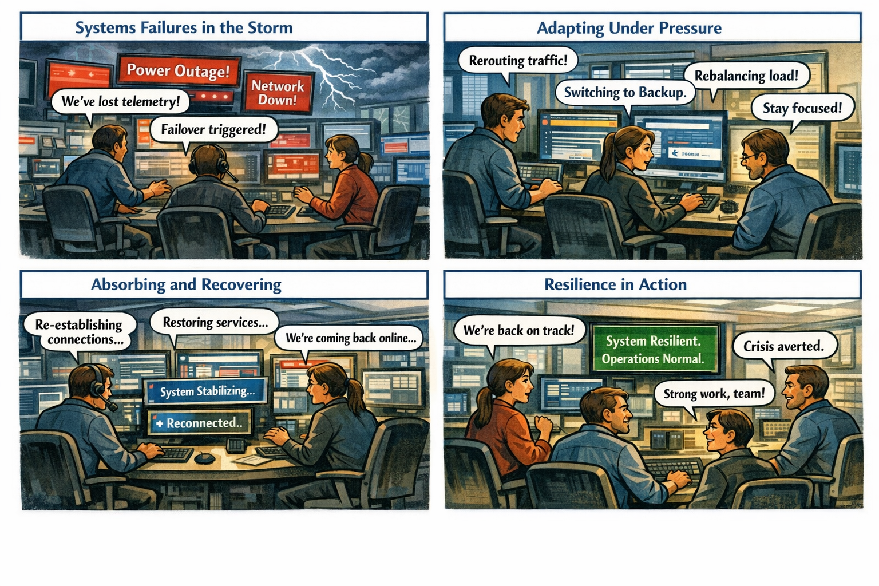

Resilience Is the Final Layer of Modernization
Visibility shows what is happening. Continuity preserves identity across transitions. Control determines what the system is allowed to do. Signals carry the truth. Evaluation interprets the truth. Decision enforces the truth. Automation scales the enforcement. Remediation repairs the damage. Recovery restores coherence. Stability maintains equilibrium.
Resilience is what remains when all other layers are stressed. It is not perfection or uptime. It is the ability to absorb failure and continue functioning.

Why GCC‑Moderate Breaks Resilience
The FedRAMP Moderate boundary was built for containment, not adaptation. It filters signals, delays response, fragments context, and isolates recovery logic. Resilience engines receive partial truth, delayed posture, inaccurate region awareness, and distorted risk signals. The system cannot adapt to what it cannot see. It does not fail because it is weak — it fails because it is blind.

Headquarters and Field Offices Experience Resilience Differently
At headquarters, resilience behaves like a self‑healing mesh. Disruptions are absorbed, sessions reroute, trust persists. In field offices, resilience behaves like a brittle chain. Disruptions cascade, sessions collapse, trust evaporates. The same user, same device, same request — different outcome. The architecture creates two realities, and resilience enforces both.

Why Resilience Failures Are Misdiagnosed
When resilience collapses, every team sees a different symptom. Security sees repeated resets. Identity sees posture loops. Network sees failover churn. Operations sees region drift. Users see unpredictability. Everyone is correct, and everyone is wrong. The failure is architectural. Resilience is reacting to the uncertainty created by the boundary.

Modernization Stalls Without Resilience
Without resilience, sessions collapse, policies misfire, trust loops emerge, access contradicts itself, recovery fails, stability oscillates, users lose confidence, and teams chase phantom failures. This is not a reliability problem. It is architectural fragility under stress.

The Root of the Resilience Problem
The resilience problem is not caused by bad failover logic, misconfigured thresholds, or user error. It is caused by an architecture that cannot absorb uncertainty without collapsing. The boundary filters the truth. The WAN delays the truth. The inspection layers distort the truth. The region model mislabels the truth. The identity platform receives partial truth. Resilience cannot function on partial truth. Resilience cannot adapt inside a fog.

The Only Way Forward
Resilience integrity must be restored. Identity‑critical signals must pass. Timing must be preserved. Region awareness must be accurate. Device posture must be current. Risk evaluation must be complete. Session context must be intact. Policy logic must receive the full truth. Only then can the system absorb failure without collapsing. Only then can trust remain predictable. Only then can modernization move forward without fragility.

Disclaimer
Not all agencies will experience the issues described in this article. These behaviors occur primarily in architectures where cloud identity, Conditional Access, and real‑time policy evaluation depend on signals that traverse GCC‑Moderate boundaries, WAN inspection layers, or region‑variable paths. Agencies with direct Active Directory authentication, on‑premises identity controllers, or short, stable network paths may see different outcomes. These observations reflect common patterns in GCC‑Moderate cloud environments, not universal conditions.

About the Author
Michal Doroszewski is a technology strategist focused on cloud architecture, identity platforms, and federal modernization. He writes about the structural and architectural forces that shape government IT, translating complex technical constraints into clear, accessible narratives for leaders and practitioners.

